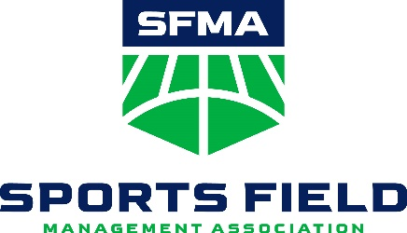
Consider a Career in Sports Field Management

Managing sports fields as a career is a rewarding and significant occupation. Join a profession that is growing and will endure as long as there are sports!

This is an ideal career if you: (just be interested in one or more of the following and you are a solid fit for this profession!)
- Enjoy the outdoors
- Are involved in sports and want to stay involved
- Consider yourself a sports fan
- Want to use emerging technology such as drones, GPS, robotic equipment, and hi-tech turf apps
- Care about protecting the environment
- Interested in the art and science of creating and maintaining beautiful and safe fields for athletes
- High School, Vo-Tech or University education programs in agriculture, landscaping design or maintenance

How to pursue:
- Traditional education
  - Attend a 2-year or 4-year collegiate program majoring in turfgrass management
- Non-traditional:
  - Take SFMA 101 on-line FREE Certificate Course (just need to be a student member at $30). Go to sportsfieldmanagement.org. Students have one year to complete the course; some students finish it in one week! Each student who completes the course will receive a certificate of course completion. Achieving the certificate will prepare you to start a career at a sports field.
  - Local College or University online Certification in Sports Field Management .
  - Online Certification at non-local College or University.
  - Apprentice at a sports field.

Job Outlook
There are more than 50 million acres of turfgrass in the United States, and the green industry is projected to be a $147 billion dollar industry. The environmental horticulture industry, which includes the turfgrass industry, is one of the fastest growing segments of the nation’s agricultural economy with an estimated 1,964,339 jobs. It is estimated that there are more than 1 million sports fields in the United States. With more than 300 professional facilities, 3,500 colleges & universities, 7,800 parks and recreation districts, and 20,000+ school districts, jobs in the sports field management profession are abundant.

Salary
The average starting salary for a first assistant is $44,000.

**CUSTOMIZE: Chapter LOGO & INFO
Whatever you want them to know about your chapter , i.e. to see the profession in action, come to our next chapter event, ETC…. (Be sure to tell them you will feed them!) For more information contact XXXXX

We are an affiliated chapter of the national professional association, Sports Field Management Association (SFMA). Its more than 2,700 members oversee facilities at schools, colleges and universities, parks and recreational facilities, and professional sports stadiums. Sports include football, baseball, soccer, lacrosse, softball, rugby and horse racing. SportsfieldManagement.org; @FieldExperts

