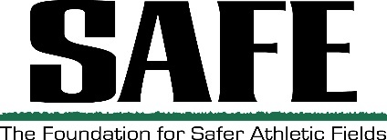
Leo Goertz Membership Grant presented by Pioneer
Criteria for Consideration
The Leo Goertz Membership Grant is for a 2-year National SFMA Membership

- Nominee must be a Sports Field Manager or member of a crew managing sports fields
- Nominee has not been an SFMA member for 5 years
- Can be self-nominated or nominated by fellow employee or any SFMA Member or SFMA Chapter Member
- Only eligible to win once
Name of Nominator Nominator’s Phone
Name/Nominated Candidate
Facility Name Address
City State Zip
Cell Phone OR E-Mail
Job Title

Please answer the following question. Attach a separate page, if needed. 150 words or less:
Why do you think this person would benefit from being an SFMA member?
(or, if self-nominated) What do you hope to gain by becoming an SFMA member?

